Title of report: FIFA21 Data Cleaning — Task Report
Prepared for: Mr Umair
Prepared by: Mohsin Saeed
09-Jun-26

Contents
Objective 3
Libraries Used 3
Data Cleaning Steps 3
1. Load Dataset and Remove Duplicates 3
2. Rename Column 3
3. Handle Hits Column 3
4. Clean Height and Weight 3
5. Clean Columns 4
6. Encode Categorical Columns 4
7. Drop Unnecessary Columns 4
8. Split Contract Column 4
9. Players with More Than 10 Years at Club 4
10. Identify Underpaid Players 4
11. Split Joined Date Column 4
12. Remove Newline Characters 4
13. Remove Outliers 5
14. MinMax Scaling 5
15. Balance Target Column 5
16. Visualization — Before and After Balancing 5
Conclusion 5

Objective
The objective of this task was to perform complete end-to-end data cleaning and preprocessing on the FIFA21 raw dataset containing 18,979 player records and 77 columns, preparing it for further analysis and machine learning model training.

Libraries Used
import numpy as np
import pandas as pd
import missingno as msno
from sklearn.preprocessing import LabelEncoder, MinMaxScaler
import matplotlib.pyplot as plt

Data Cleaning Steps

1. Load Dataset and Remove Duplicates
Dataset was loaded and duplicate rows were removed to ensure data quality .

2. Rename Column
The column with a special arrow character was renamed for better readability and accessibility. The rename() function allows renaming specific columns by passing a dictionary, where keys are the old column names and values are the new column names.

3. Handle Hits Column
The Hits column contained string values with K suffix and null values. K was removed, converted to float, and null values were filled with mode.

4. Clean Height and Weight
Units were removed from Height and Weight columns and converted to numeric format. str.replace() method is the most simple and efficient way.

5. Clean Columns
A custom function was created to remove Euro symbols and convert M and K suffixes to actual numeric values using multiplication.

6. Encode Categorical Columns
Label Encoding was applied to categorical columns to convert them into numerical format for model compatibility. The labels are assigned in alphabetical order not based on their position in the dataset

7. Drop Unnecessary Columns
Loan Date End column was dropped as it contained 17,966 null values out of 18,979 rows making it unusable.

8. Split Contract Column
The Contract column containing date ranges was split into separate Contract Start and Contract End columns for better feature extraction.

9. Players with More Than 10 Years at Club
Players who have been at their current club for more than 10 years were identified using the Joined column. pandas.to_datetime() converts argument(s) to datetime. This function is essential for working with date and time data

10. Identify Underpaid Players
Average wage was calculated and players earning below the 35th percentile were identified as underpaid.

11. Split Joined Date Column
The Joined column was split into separate year, month, and day columns for better feature engineering.

12. Remove Newline Characters
All object type columns were stripped of unnecessary newline characters. function looks for all matches of the pattern \n in text.

13. Remove Outliers
Method identifies outliers by measuring the spread between the first quartile (Q1) and third quartile (Q3). Any data point below $Q1-1.5*IQR$ or above $Q3+1.5*IQR$is considered an outlier.

14. MinMax Scaling
The MinMaxScaler rescales features to a fixed range, usually [0,1]. Unlike standardization, it does not change the distribution shape of the data; it only shifts and scales values so that the minimum feature value maps to the lower bound and the maximum maps to the upper bound.

15. Balance Target Column
The Preferred Foot column was balanced using groupby and random sampling to resolve class imbalance.

16. Visualization — Before and After Balancing
Bar charts were plotted to compare the distribution of Preferred Foot before and after balancing. 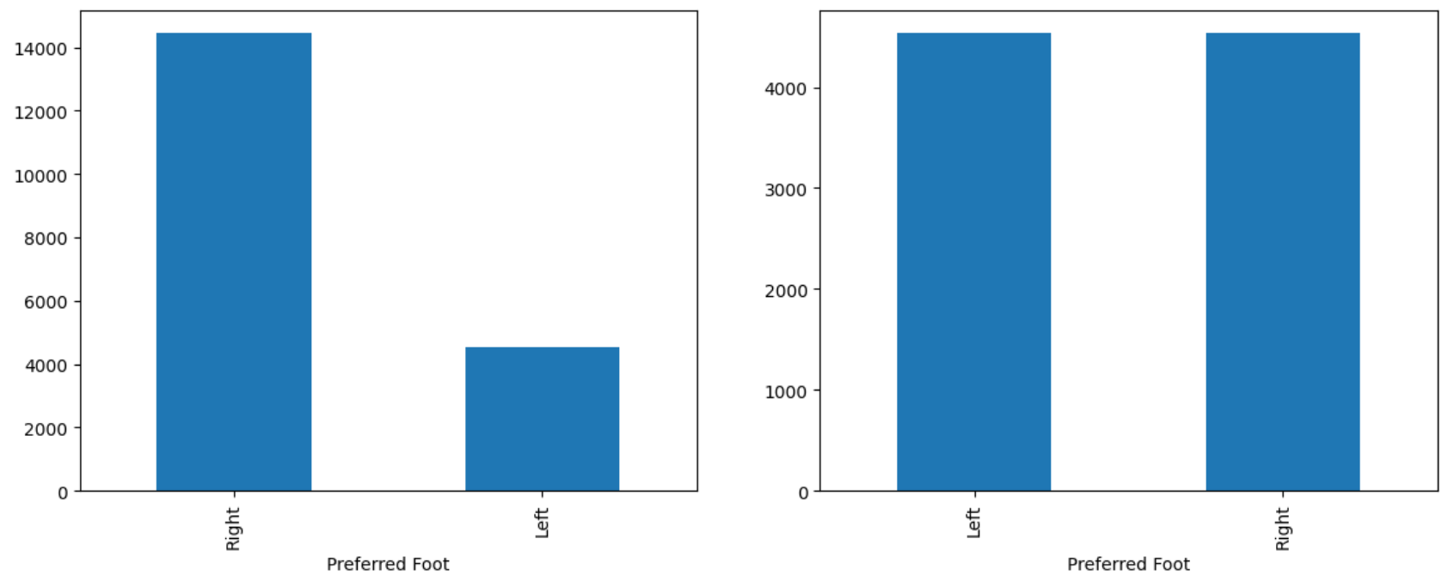

Conclusion
This task successfully completed end-to-end data cleaning and preprocessing on the FIFA21 dataset. Duplicate records were removed, column names were standardized, and missing values in the Hits column were handled using mode imputation. Monetary columns containing currency symbols and suffixes were converted to proper numeric format using a custom lambda-style function. Categorical columns were encoded using Label Encoder and unnecessary columns were dropped. The Contract column was split into start and end year features and the Joined column was decomposed into year, month, and day components. Players with more than 10 years at their club and underpaid players were identified through analytical queries. Class imbalance in the target column Preferred Foot was resolved using groupby sampling and the results were confirmed through before and after visualizations. The dataset is now clean, structured, and fully ready for model training.

